

**TECHNICAL PROPOSAL:**

**HIGHER EDUCATION PLATFORM.**

**(RFI No: 850898,1)**

**For: MINISTRY OF EDUCATION (MOE)**

**Submitted by:**

Verbanet Technologies LLC   
26.07.20

**DIRECTORY.**

1 KEY DETAILS. 5

2 EXECUTIVE SUMMARY 6

2.1 PROPOSED SOLUTION MODEL 7

3 FUNCTIONAL REQUIREMENTS 7

3.1 STUDENT JOURNEY 9

3.2 SCHOLARSHIP STUDENT JOURNEY 11

3.3 UNIVERSITY JOURNEY 14

3.4 EDUCATION SERVICES PROVIDER JOURNEY 16

3.5 EDUCATION PROFESSIONAL JOURNEY 17

3.6 WORKFORCE EMPLOYEE JOURNEY 19

3.7 RESEARCHER JOURNEY 20

3.8 SUPPORT SYSTEM 21

3.8.1 CHAT 22

3.8.2 RAISE ISSUE 22

3.9 FEEDBACK SYSTEM 22

3.10 ADMIN MODULES 22

3.11 INTEGRATIONS AND AUTOMATION 23

3.12 BATCH JOBS 23

3.13 MOBILE APPLICATION 23

4 SYSTEM STUDY 24

4.1 DELIVERABLES 25

5 BUILD AND TEST 26

6 NON-FUNCTIONAL REQUIREMENT (OTHERS) 29

6.1 Supporting Languages 29

6.2 Access control 29

6.3 Integration 29

6.4 Security 29

6.5 Responsive screens 29

6.6 Browser Compatibility 29

7 PROPOSED TECHNOLOGY STACK 30

7.1 Server Side 30

7.2 Client Side 30

7.3 Database 30

7.4 Tools 30

7.5 Protocols 30

7.6 Programming / Scripting Languages 30

7.7 Mobile Application Technology 31

7.7.1 SUPPORTING OS 31

7.7.2 SUPPORTING SCREEN RESOLUTIONS 31

7.7.3 TECHNICAL GUIDELINES 31

8 DEVELOPMENT PRATCICES 32

8.1 Source Code Management 32

8.2 Development guidelines 32

8.2.1 Dot Net guidelines 32

8.3 Middle Tier implementation 33

8.4 Logging / auditing mechanism 34

8.5 Performance Requirements 35

9 SYSTEM SECURITY 35

9.1 Authentication 35

9.2 Cryptographic usage 36

9.3 Secure error handling – fail safe 36

9.4 Requirements of External Interfaces 36

9.4.1 Communication Interfaces 36

9.4.2 Security Standards 37

9.4.3 Smart Device(s) Compatibility 37

10 ARCHITECTURE 38

10.1 TECHNOLOGY ARCHITECTURE 38

10.2 Hosting Architecture – Test & Production 39

11 PROJECT ASSUMPTIONS 39

11.1 OBJECTIVE 39

11.2 DESIGN 40

11.3 DEVELOPMENT 40

12 PROJECT DELIVERY 41

12.1 PROJECT MANAGEMENT / PROJECT APPROACH 41

12.2 ROLES & RESPONSIBILITIES 41

12.2.1 Project Team 42

12.2.2 Project Organization Plan and Stakeholder Analysis Plan 43

12.3 COMMUNICATION MANAGEMENT PLAN 43

12.4 SCOPE MANAGEMENT PLAN 45

12.5 QUALITY MANAGEMENT PLAN 45

12.6 TIME MANAGEMENT 45

12.7 RISK CONTINGENCY PLAN 46

12.8 PROJECT IMPLEMENTATION PLAN 47

12.9 DELIVERABLES 47

12.10 ESTIMATED DELIVERY TIME 48

12.11 RELEASE PLANNING 49

13 OUT OF SCOPE 49

14 CHANGE MANAGEMENT 50

15 MAINTENANCE & SUPPORT 52

16 TERMS AND CONDITIONS 53

16.1 ACCEPTANCE CRITERIA 53

16.2 WARRANTY 53

16.3 SOURCE CODE & INTELLECTUAL PROPERTY RIGHTS 53

16.4 GENERAL TERMS AND CONDITIONS 54

16.5 GENERAL ADMINISTRATIVE, TECHNICAL & FUNCTIONAL ASSUMPTIONS 55

17 Project References 56

# KEY DETAILS.

**PROJECT NAME CLIENT**

Higher Educational Platform Ministry of Education (MOE)

**CLIENT CONTACT CLIENT ADDRESS**

Shamsa Mohammed Erhama bin Bakhit Dubai, UAE

shamsa.alfalasi@moe.gov.ae

**PROPOSAL SUBMISSION PROPOSAL ID NO.**

26.07.20AD/TP/26072020/3918/1

**PROPOSAL VALID UNTIL ANTICIPATED START DATE**

25.10.20 TBD

**PROPOSAL SUBMITTED BY PROPOSED TECHNOLOGY**

Joyce Daniel .Net Core, ASP.NET, Phone Gap

Verbat Technologies

Dubai, U.A.E **APPLICATION TYPE**

+971 4 297 3236Responsive Web Application and Cross

Joyce.daniel@verbat.com Platform Mobile Application

# EXECUTIVE SUMMARY

The Ministry of Higher Education responsible for regulating the higher education sector in the UAE has undergone a merger with the Ministry of Education responsible for General Education (at the time). The merger also covered the inclusion of Early Child education under one single umbrella named Ministry of Education (MOE).

The merger has resulted in a new vision, mandate, roles, responsibilities and organization structure for the new MOE’s Higher Education Affairs (MOEHEA) including the introduction of four new specialist functional areas (depts.), hence expanding its core business operation.

In addition to existing core business depts., which are Commission of Academic Accreditation (CAA), Scholarships, Equivalency & Attestation, Student Registration & Counselling and Scientific Research; new core business depts. were added which include; Licensing and Institutional Accreditation, ~~Teacher~~ Professional Licensing, Evaluation & Quality and Graduate Affairs & Labour Market. In view of the mandate, vision and strategy of the new MOE, MOEHEA has commissioned a project to define its vision and strategy for 2030 taking into account the strategy of the UAE and its national agenda. This new vision and strategy are centered around students, institutions and the educational system

Ministry of Education (MOE), (hereafter referred to as “Client”) has approached Verbanet Technologies L.L.C., (hereafter referred to as” Verbat”) to design, develop and Implement an integrated Higher Educational Platform of new operational systems, eservices portal and smart services to support its business operations.

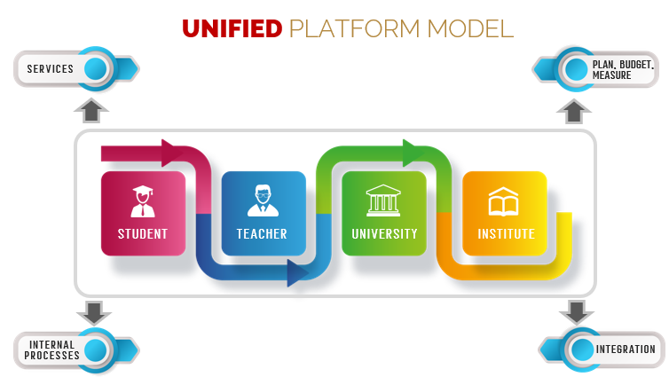

Verbat is pleased to submit the proposal and values it as a great opportunity to have a long term & mutually beneficial association with the Client. Verbat has gone through the requirement and presents a Technical Proposal for the requested system.

## PROPOSED SOLUTION MODEL

**STAND- ALONE FIXED BID**

Verbat will be following a stand–alone fixed bid solution delivery model wherein the required solution would be devised and a suitable pricing would be offered.

# FUNCTIONAL REQUIREMENTS

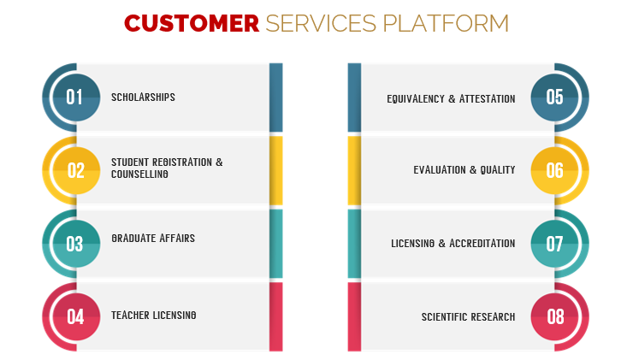

The scope of the project is to develop an Integrated Higher Educational platform which includes, among others, the following systems:

* Scholarship management system and e-services.
* Equivalency and attestation management system and e-services.
* Student registration, admission and eligibility management system (NAPO) and e-services.
* Unified accreditation management system and services, which cover:
  + Programme accreditation.
  + Institutional licensing and accreditation.
  + Evaluation and quality.
  + Compliance.
* ~~Teacher~~ Professional licensing and qualifications management system and services.
* Scientific research management system and services.
* Graduate affairs and labour market management system and services.
* All Integration and interface points (external and internal).
* Payment Gateway Integration
* E-services’ portal (improvement recommendations only)
* Smart (mobile) services.

## STUDENT JOURNEY

|  |  |
| --- | --- |
| **Web site Content** |  |
| 1 | Home page |
| 2 | Awareness |
| 3 | Manage Student Affairs |
| 4 | Identify Internship Opportunities for University Students |
| 5 | Manage Degree Equivalency |
| **Content Management** |  |
| **1** | Admin panels for the content management |
| **Dashboard** |  |
| 1 | My pending actions |
| 2 | My actioned items |
| 3 | My open requests |
| 4 | My closed requests |
| 5 | Filters, Sorting & Export |
| **Process / Workflows** |  |
| 1 | Apply & Receive Acceptance |
| **Admin** |  |
| 1 | Look up values |
| 2 | Approval matrix |
| **Reports** |  |
| 1 | Journey related KPIs |
| 2 | Satisfaction rates of students against key moments that matter (e.g. outreach plan, etc.) |
| 3 | Number of student applications received (3-year trend minimum) |
| 4 | Percentage of degrees positive secondary education equivalency statements |
| 5 | Percentage of students accepted into at least one of their top 2 choices (3-year trend minimum) |
| 6 | Percentage of incomplete applications out of the total application pool |
| 7 | Utilization of HE programs aligned to Labor Market Strategy |
| 8 | Total number of internships provided and total number completed in private sector by field |
| 9 | Graduate employment within 6 months by field (3-year trend minimum) |
| 10 | Shifts and trends in the UAE labor market and degree of alignment with the higher education sector |
| 11 | Satisfaction rate of employers with graduates by field (3-year trend minimum) |

## SCHOLARSHIP STUDENT JOURNEY

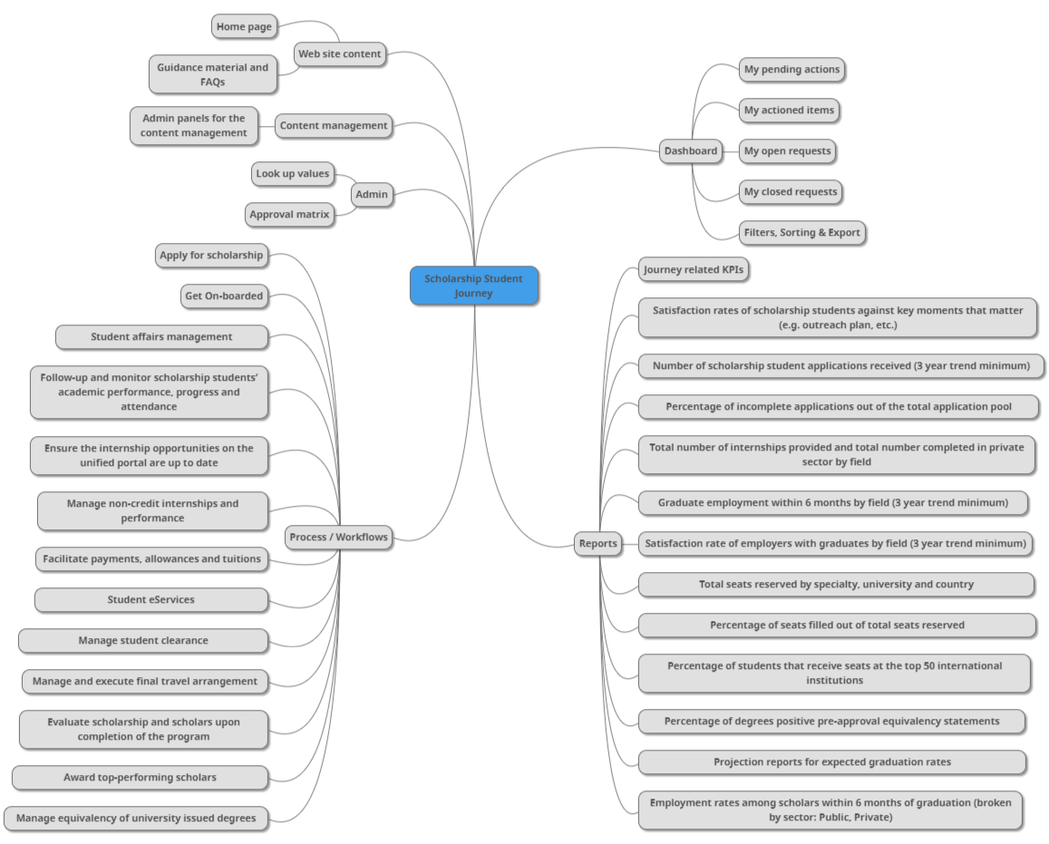

|  |  |
| --- | --- |
| **Web site Content** |  |
| 1 | Home page |
| 2 | Guidance material and FAQs |
| **Content Management** |  |
| 1 | Admin panels for the content management |
| **Dashboard** |  |
| 1 | My pending actions |
| 2 | My actioned items |
| 3 | My open requests |
| 4 | My closed requests |
| 5 | Filters, Sorting & Export |
| **Process / Workflows** |  |
| 1 | Apply for scholarship |
| 2 | Get On-boarded |
| 3 | Student affairs management |
| 4 | Follow-up and monitor scholarship students’ academic performance, progress and attendance |
| 5 | Ensure the internship opportunities on the unified portal are up to date |
| 6 | Manage non-credit internships and performance |
| 7 | Facilitate payments, allowances and tuitions |
| 8 | Student eServices |
| 9 | Manage student clearance |
| 10 | Manage and execute final travel arrangement |
| 11 | Evaluate scholarship and scholars upon completion of the program |
| 12 | Award top-performing scholars |
| 13 | Manage equivalency of university issued degrees |
| **Admin** |  |
| 1 | Look up values |
| 2 | Approval matrix |
| **Reports** |  |
| 1 | Journey related KPIs |
| 2 | Satisfaction rates of scholarship students against key moments that matter (e.g. outreach plan, etc.) |
| 3 | Number of scholarship student applications received (3 year trend minimum) |
| 4 | Percentage of incomplete applications out of the total application pool |
| 5 | Total number of internships provided and total number completed in private sector by field |
| 6 | Graduate employment within 6 months by field (3 year trend minimum) |
| 7 | Satisfaction rate of employers with graduates by field (3 year trend minimum) |
| 8 | Total seats reserved by specialty, university and country |
| 9 | Percentage of seats filled out of total seats reserved |
| 10 | Percentage of students that receive seats at the top 50 international institutions |
| 11 | Percentage of degrees positive pre-approval equivalency statements |
| 12 | Projection reports for expected graduation rates |
| 13 | Employment rates among scholars within 6 months of graduation (broken by sector: Public, Private) |

## UNIVERSITY JOURNEY

|  |  |
| --- | --- |
| **Web site Content** |  |
| 1 | Home page |
| **Content Management** |  |
| 1 | Admin panels for the content management |
| **Dashboard** |  |
| 1 | My pending actions |
| 2 | My actioned items |
| 3 | My open requests |
| 4 | My closed requests |
| 5 | Filters, Sorting & Export |
| **Process / Workflows** |  |
| 1 | Establish a New University or New Program |
| 2 | Undergo Quality Assurance and Compliance Inspection |
| 3 | Process Renewal of Institutional Licensure |
| 4 | Process Renewal of Program Accreditation |
| 5 | Manage application for Substantive Institutional change |
| 6 | Manage application for Substantive Program change |
| 7 | Manage application for Institutional Closure or Campus Branch Closure |
| 8 | Manage application for Program Closure |
| **Admin** |  |
| 1 | Look up values |
| 2 | Approval matrix |
| **Reports** |  |
| 1 | Journey related KPIs |
| 2 | Satisfaction rates among Universities with the overall HEI licensing process |
| 3 | Satisfaction rates among Reviewers with the overall HEI review process |
| 4 | Total number of licenses applied for by year |
| 5 | Status of licenses applied for (e.g. granted, revoked, etc.) |
| 6 | Average time taken to issue institutional license |
| 7 | Variance between total cost requested from universities initially and total amount actually paid |
| 8 | Themes emerging from university visits and data collected |

## EDUCATION SERVICES PROVIDER JOURNEY

|  |  |
| --- | --- |
| **Web site content** |  |
| 1 | Home page |
| **Content Management** |  |
| 1 | Admin panels for the content management |
| **Dashboard** |  |
| 1 | My pending actions |
| 2 | My actioned items |
| 3 | My open requests |
| 4 | My closed requests |
| 5 | Filters, Sorting & Export |
| **Process / Workflows** |  |
| 1 | Apply for/Receive License |
| 2 | Maintain Licensing Status |
| 3 | Apply for License Renewal |
| 4 | Application for License Transfer |
| 5 | Application for License Cancellation |
| **Admin** |  |
| 1 | Look up values |
| 2 | Approval matrix |
| **Reports** |  |
| 1 | Journey related KPIs |
| 2 | Satisfaction rates among Education Services Providers with the overall licensing process |
| 3 | Satisfaction rates among reviewers with the overall Education Services Provider review process |
| 4 | Total number of licenses applied for by year |
| 5 | Status of licenses applied for (e.g. granted, revoked, etc.) |
| 6 | Average time taken to issue license |

## EDUCATION PROFESSIONAL JOURNEY

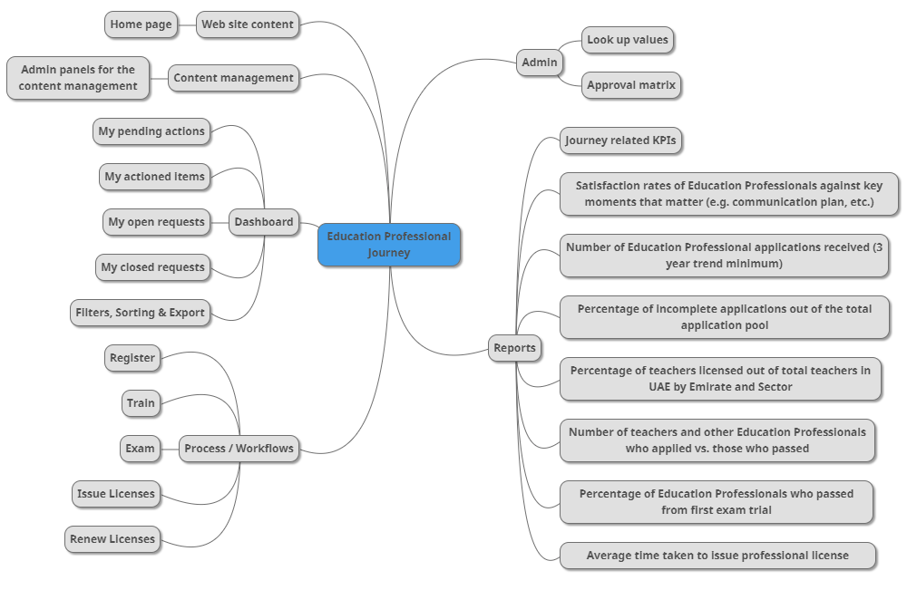

|  |  |
| --- | --- |
| **Web site Content** |  |
| 1 | Home page |
| **Content Management** |  |
| 1 | Admin panels for the content management |
| **Dashboard** |  |
| 1 | My pending actions |
| 2 | My actioned items |
| 3 | My open requests |
| 4 | My closed requests |
| 5 | Filters, Sorting & Export |
| **Process / Workflows** |  |
| 1 | Register |
| 2 | Train |
| 3 | Exam |
| 4 | Issue Licenses |
| 5 | Renew Licenses |
| **Admin** |  |
| 1 | Look up values |
| 2 | Approval matrix |
| **Reports** |  |
| 1 | Journey related KPIs |
| 2 | Satisfaction rates of Education Professionals against key moments that matter (e.g. communication plan, etc.) |
| 3 | Number of Education Professional applications received (3-year trend minimum) |
| 4 | Percentage of incomplete applications out of the total application pool |
| 5 | Percentage of teachers licensed out of total teachers in UAE by Emirate and Sector |
| 6 | Number of teachers and other Education Professionals who applied vs. those who passed |
| 7 | Percentage of Education Professionals who passed from first exam trial |
| 8 | Average time taken to issue professional license |

## WORKFORCE EMPLOYEE JOURNEY

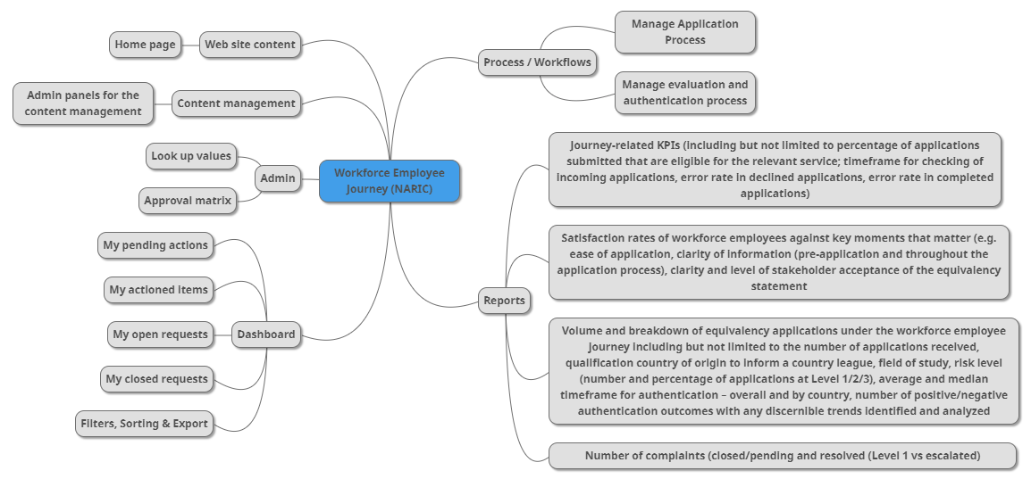

|  |  |
| --- | --- |
| **Web site Content** |  |
| 1 | Home page |
| **Content Management** |  |
| 1 | Admin panels for the content management |
| **Dashboard** |  |
| 1 | My pending actions |
| 2 | My actioned items |
| 3 | My open requests |
| 4 | My closed requests |
| 5 | Filters, Sorting & Export |
| **Process / Workflows** |  |
| 1 | Manage Application Process |
| 2 | Manage evaluation and authentication process |
| **Admin** |  |
| 1 | Look up values |
| 2 | Approval matrix |
| **Reports** |  |
| 1 | Journey-related KPIs (including but not limited to percentage of applications submitted that are eligible for the relevant service; timeframe for checking of incoming applications, error rate in declined applications, error rate in completed applications) |
| 2 | Satisfaction rates of workforce employees against key moments that matter (e.g. ease of application, clarity of information (pre-application and throughout the application process), clarity and level of stakeholder acceptance of the equivalency statement |
| 3 | Volume and breakdown of equivalency applications under the workforce employee journey including but not limited to the number of applications received, qualification country of origin to inform a country league, field of study, risk level (number and percentage of applications at Level 1/2/3), average and median timeframe for authentication – overall and by country, number of positive/negative authentication outcomes with any discernible trends identified and analyzed |
| 4 | Number of complaints (closed/pending and resolved (Level 1 vs escalated) |

## RESEARCHER JOURNEY

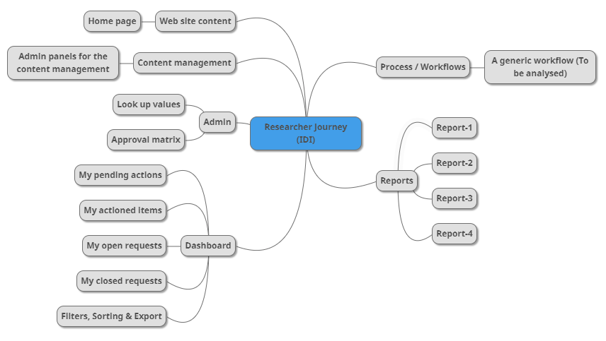

|  |  |
| --- | --- |
| **Web site Content** |  |
| 1 | Home page |
| **Content Management** |  |
| 1 | Admin panels for the content management |
| **Dashboard** |  |
| 1 | My pending actions |
| 2 | My actioned items |
| 3 | My open requests |
| 4 | My closed requests |
| 5 | Filters, Sorting & Export |
| **Process / Workflows** |  |
| 1 | Generic workflow |
| **Admin** |  |
| 1 | Look up values |
| 2 | Approval matrix |
| **Reports** |  |
| 1 | Report-1 |
| 2 | Report-2 |
| 3 | Report-3 |
| 4 | Report-4 |

## SUPPORT SYSTEM

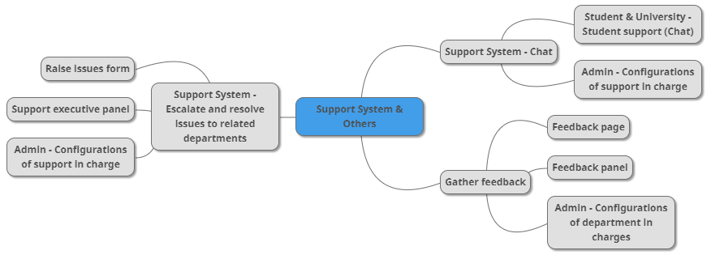

### CHAT

|  |  |
| --- | --- |
|  | **Support System - Chat** |
| 1 | Student & University - Student support (Chat) |
| 2 | Admin - Configurations of support in charge |

### RAISE ISSUE

|  |  |
| --- | --- |
|  | **Support System - Escalate and resolve issues to related departments** |
| 1 | Raise issues form |
| 2 | Support executive panel |
| 3 | Admin - Configurations of support in charge |

## FEEDBACK SYSTEM

|  |  |
| --- | --- |
|  | **Gather feedback** |
| 1 | Feedback page |
| 2 | Feedback panel |
| 3 | Admin - Configurations of department in charges |

## ADMIN MODULES

|  |  |
| --- | --- |
|  | **Gather feedback** |
| 1 | Feedback page |
| 2 | Feedback panel |
| 3 | Admin - Configurations of department in charges |

* Admin - Manage second level admins
* Master data management
* Settings

## INTEGRATIONS AND AUTOMATION

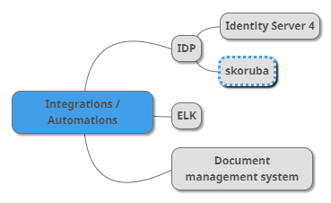

**Keycloak**

|  |  |
| --- | --- |
|  | **Integrations / Automations** |
| 1 | IDP – Identity Management Using Keycloak |
| 2 | ELK – Search, Index and Retrieve |
| 3 | Document management system |

## BATCH JOBS

One or multiple jobs may need to be implemented in order to integrate with different business systems and legacy systems. More details would be collected during the requirement gathering phase. The batch jobs will generate logs which will be used for audit tracking.

## MOBILE APPLICATION

* This model of phone application will be developed using Ionic framework.
* Only the workflows are considered in this mobile application scope
* The web content of the web site is not considered in scope.
* Reports are not in mobile application scope as it is meant for admin users, not for public users.
* Home page shows “+” icon. On clicking it, the list of different applications will be shown. By selecting the appropriate application, the corresponding new request form will be shown. Users can key in the details and submit for the approvals.
* Offline support is not considered

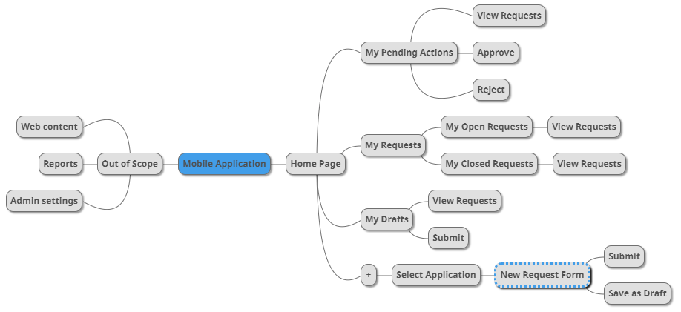

# SYSTEM STUDY

Project System Study Phase will include:

* Overall review of the TO-BE business processes to derive system and operational requirements (such as internal and external integration, dependencies and others) for all MOEHEA’s departments.
* Review of TO-BE business processes from the IT systems perspective to define IT systems requirements
* The business review and requirements analysis will cover core functions, integrating points and dependencies for all MOEHEA’s depts. which include:
  + Commission of Academic Accreditation (CAA).
  + Equivalency and Attestation.
  + Student Registration and Counselling (NAPO).
  + Licensing and Accreditation.
  + Professional licensing.
  + Scientific Research.
  + Evaluation and Quality.
  + Scholarships.
  + Graduate Affairs and Labour Market.
* Business review and system requirement analysis to cover all processes, operational policies, and procedures with a view to distil automation requirements. For each department the following items will be reviewed.
  + All functions.
  + Governance processes (e.g. Committees) to support daily business processes.
  + Relationships, integration points and dependencies with:
    - Other MOEHEA departments and functions.
    - Cultural Attachés (which are an integral part of MOEHEA’s departments).
    - Other MOE common and support functions (e.g. HR, Finance, Procurement, Customer Service Centers, Call Centre, Gov. Communication, Institutional development, Data and Stats Centre and others)
    - External government organizations and entities.
  + Customer management and customer services.
* Review and analysis to cover the mandate and operation of governance structures
* Review of the process integration and dependencies between MOEHEA’s depts. and Cultural Attachés (CAs).
* Review of all relationships, integration points and dependencies between MOEHEA’s departments and support functions in the context of integration with the daily operation of MOEHEA’s departments.
* Review to cover all relationships, integration points and dependencies with external entities.
* Review of all MOEHEA’s services offered to customers in terms of service portfolio and fulfilment model.
* Identification of new services (for new departments) and areas for improvement for existing ones (if any).
* Review of current IT systems for MOEHEA to identify weaknesses and gaps as well as draw recommendations for the new systems

## DELIVERABLES

* High-level description of the ‘AS IS’ state with detailed gaps, weaknesses, areas for improvement and recommendations from a system’s point of view in relation to the provided TO-BE processes.
* High-level description (design) of the ‘To Be’ Integrated Higher Education platform covering all the areas described above.

# BUILD AND TEST

Verbat’s philosophy has been to deliver products that allowed clients to be intimately involved with the development activity. As early as 2005 Verbat had adopted the agile development practices into its pipeline for software development. This allowed clients to closely observe the product being developed. It created a tight feedback loop that allowed us, along with our clients to better understand the requirements and build a right sized and proportional product.

With the advent of next generation applications and tools that support a wide range of activities related to development, deployment and integration; the feedback loops became tighter and coupled, while at the same time it allowed us to create applications that were decoupled. Thus giving us the capability to have greater flexibility in development and deployment.

While development broke down the barrier between developers and management, Devops broke the barrier between software developers and operations teams. Our development and operations teams work under a single silo. While our Scrum teams are cross functional, in our quest to adopt better integration with operations, we have realized that Devops is not just a set of tools and processes, but a mindset and culture. We have fostered a culture collaboration and communication.

To put this into perspective, the figure below conceptualizes Verbat’s Continuous Integration (CI) and Continuous Deployment (CD) Lifecycle

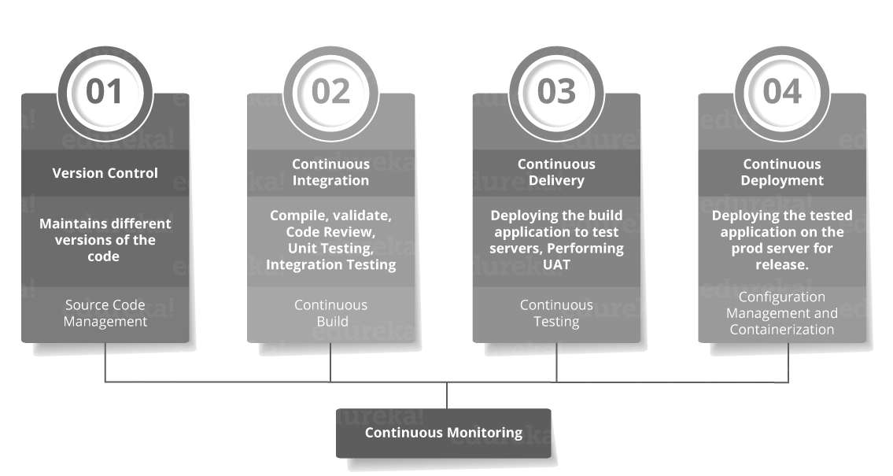This is akin to the Software Development Life Cycle (SDLC)

The pipeline below is a logical demonstration of how software will move along the various stages in this lifecycle before it is delivered to the customer or before it is live in production.

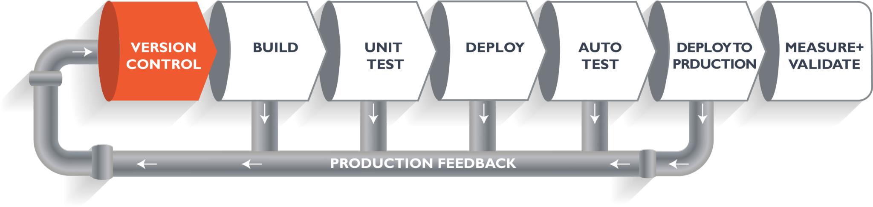

When we build a web application, our developers will commit the code into version control system (such as git, svn), which is the first phase of the pipeline. The code goes to the version control system with a proper version tag.

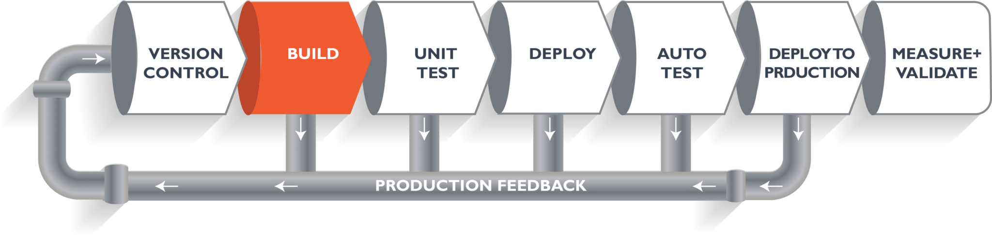Through the version control phase, it again goes to the build phase, where it is compiled with all the features of the code from various branches of the repository. The code is merged and compiled. This whole process comprises the build phase.

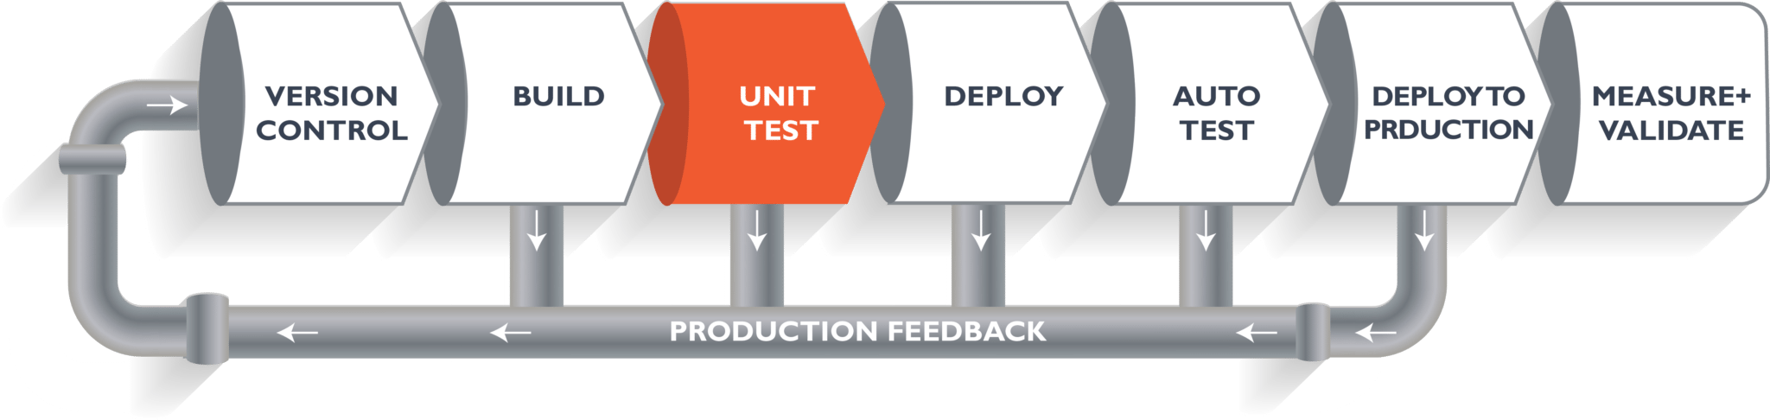Once the build phase is over, the code is moved into the testing phase. In this phase, various kinds of testing is conducted. One of them is the unit test (where a chunk/unit of software is tested for sanity).

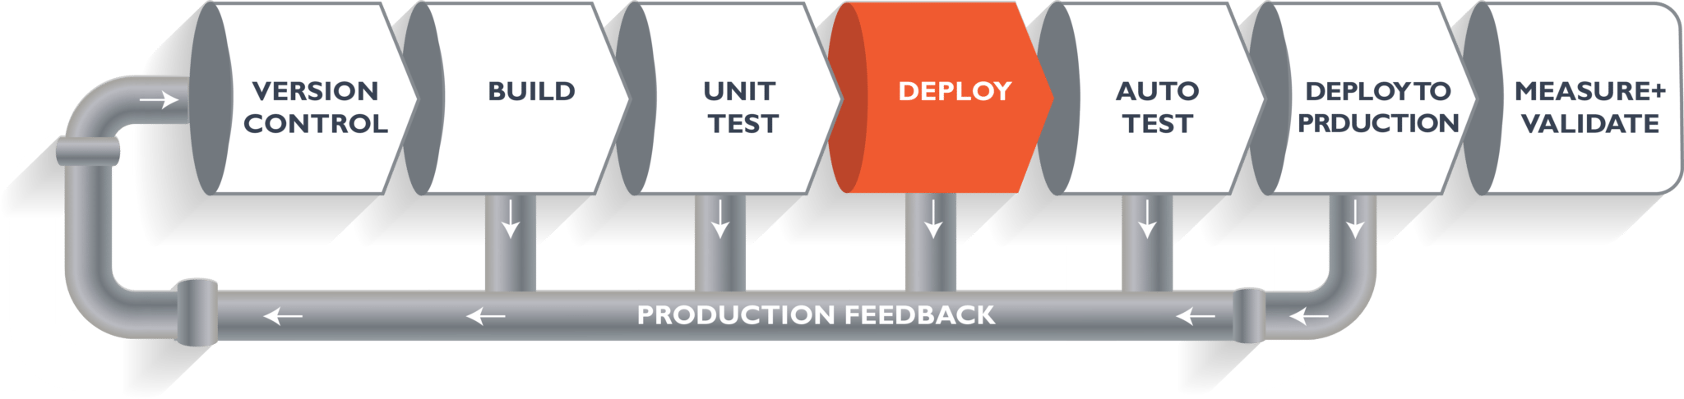When the test is completed, the code is deployed into a staging or a test server.

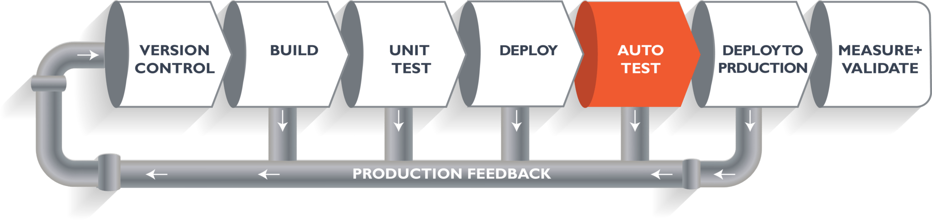

Once the code is deployed successfully, another round of sanity test is conducted. If everything is accepted, then it is deployed to production.

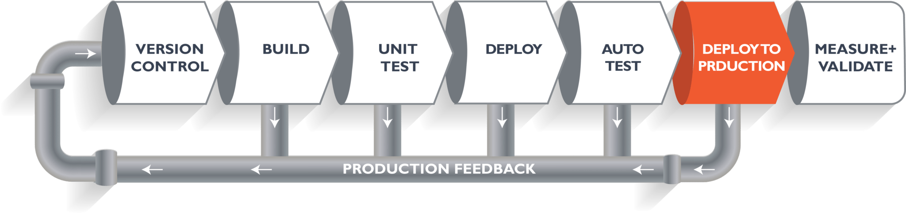

Meanwhile, in every step, if there is an error, am email is relayed to the development team so that they can fix it. Then they will push it into the version control system and it goes back into the pipeline.

Once again, if there is any error reported during testing, the feedback goes to the dev team again, where they fix it and the process reiterates if required.

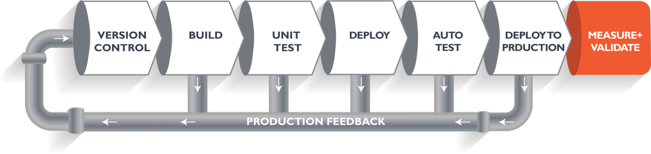This lifecycle continues until the code/a product can be measured and validated.

# NON-FUNCTIONAL REQUIREMENT (OTHERS)

## Supporting Languages

* English
* Arabic

## Access control

The data, field visibility and features will be visible and accessible only to the appropriate users of the system.

## Integration

Only SMTP server integration is required at this point in time. Further details about the integration will get to know during the requirement study.

## Security

API calls will be secured using HTTPS/SSL. TRA policies and regulations will be followed.

## Responsive screens

Web application can be viewed in different devices with different sizes and hence the user interface will be developed responsive.

## Browser Compatibility

* Google Chrome (latest released version)
* Edge (latest released version)
* Apple Safari (latest released version)

# PROPOSED TECHNOLOGY STACK

Verbat proposes Dot Net Core & ASP.Net as the primary technologies to develop this system.

## Server Side

* Dot Net Core 3.0
* Entity Framework Core
* REST APIs

## Client Side

* ASP.Net
* JSON
* Bootstrap

## Database

* SQL Server 2016 or 2019 Enterprise
* MongoDB
* MinIO (Open Source)

## Integration

* KAFKA.Net (Open Source)

## API Management

* WSO2 (Open Source)

## Search and Analytics

* ELK Stack (Open Source)

## Logging

* SYSLOG Server (Open Source)

## Authentication & Authorization

* Identity Server 4.0 (Open Source)

## Tools

* Visual Studio 2017
* Visual Studio Code
* SQL Server Management Studio

## Work Flow Management (Optional)

* Microsoft Workflow Engine

## Protocols

* HTTPS / SSL
* SMTP

## Programming / Scripting Languages

* Server Side
  + C Sharp
  + SQL
* Client Side
  + HTML
  + JavaScript
  + CSS

## Mobile Application Technology

* Apache Cordova
* HTML / CSS / JavaScript
* Ionic Framework
* REST APIs

### SUPPORTING OS

The application is reliant on hardware interfaces to provide a seamless automated user experience.

* iOS 10 and above
* Android Marshmallow (6.0) and above

### SUPPORTING SCREEN RESOLUTIONS

1080 x 1920, 720 x 1280, 750 x 1334, 640 x 1136

### TECHNICAL GUIDELINES

The guidelines provide instructions and conditions that will be adhered to during the development of the mobile application.

* API will be used, as the case may be, in realizing the features and functionalities mentioned
* The client will finalize the functional requirements and UI/UX before the commencement of the project
* The client will have to provide the details of the testing devices they are using before the start of development phase
* Client should provide the relevant Developer's Account credentials before the development phase. In case Verbat needs to create the developer id additional charges will be incurred by the client
* The duration mentioned in the project time line is for development and testing and any delay or time taken by the review team to respond will not be Verbat’s responsibility
* The apps will be developed / created within the guidelines of Android & Apple play store.
* Verbat will strictly follow the guidelines provided by the respective stores.
* Verbat will inform the client if any of the client requirements /request deviates from it.
* Customization of the features of the app will be susceptible to the limitation imposed by the respective platform/ store.
* Once development commences, the test device/screen sizes will not be susceptible to change. Any change requested by the client will have to go through change management
* OS version support will be limited to the ones mentioned in the Technology Stack. Further support will have to go through change management

# DEVELOPMENT PRATCICES

## Source Code Management

Microsoft TFS or Bitbucket are preferred for source control. Source code will be checked in at certain intervals such as, once all the testing is being done from developer end and also the cases where source code needs to be deployed to UAT with the relevant changes in place.

## Development guidelines

### Dot Net guidelines

Following guidelines will be followed during the development phase:

* Use Pascal Casing for class names and method names.
* Use camel Casing for method arguments and local variables.
* Do not use Underscores in identifiers. Exception: we can prefix private static variables with an underscore.
* Use predefined type names instead of system type names like Int16, Single, UInt64, etc.
* Use implicit type var for local variable declarations. Exception: primitive types (int, string, double, etc.) use predefined names
* Prefix interfaces with the letter I.
* Name source files according to their main classes. Exception: file names with partial classes reflect their source or purpose, e.g. designer, generated, etc.
* Organize namespaces with a clearly defined structure.
* Cleanup spaces in the code using Visual studio shortcut ctrl+K+D
* Remove unused namespaces in the code using ‘Remove and sort using’ shortcut menu.
* Remove unused variables.
* Refactor the code wherever necessary so that it can be reused.
* Add summary above classes/methods to specify the behavior of each newly created classes.

## Middle Tier implementation

REST APIs will be used in the middle tier of this system. Swagger will be used for the better documentations. Upon API development completion, a clear documentation will be provided. The documentation will address the below points:

* The interfaces and external functionality of the high-level components described in detail.
* Routine kind, name, parameters and their types, return type, pre- and post-condition, usage protocol w.r.t. other routines.
* Socket number and protocol.
* Shared variables, synchronization primitives (locks).
* Should avoid implementation details and do not describe each class in detail.

API list will be exposed as in the following screenshot:

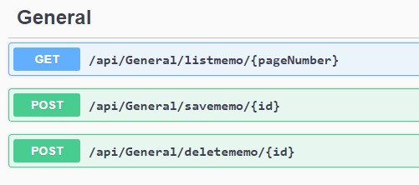

The term “api” in the above screenshot means the end point and it will be the prefix to denote that it is an endpoint for api. The api needs to be invoked by denoting the hosted URL followed by the above- mentioned endpoint.

The term “General” means the module in which the following operation is going to be taken place. This will be having modules names like HR, Legal, IT etc. This way developer will be able to understand that the operation is going to be happen in a specified module.

The terms “listmemo”, ”savememo” and “deletememo” are actual operations against the certain module. Listmemo means it will list out all the memos. Savememo means to insert or update the data. Deletememo is to delete the specific memo.

## Logging / auditing mechanism

“Syslog.Framework.Logging” component will be used to generate the log messages. The log messages will be stored in ASCII format.

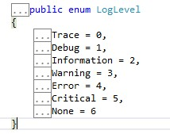Below are the log levels used in the logging capability of .net core.

We can log from any level to be captured in the database. If we mention to log each and every activity, we need to specify Information Level so that the logger will capture logs from information level and other log levels as well. If we specify Error Level, the log will be captured only when exception or critical errors are thrown.

Below is the table screenshot with columns specifying the details:

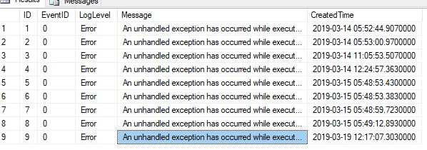

## Performance Requirements

In order to assess the performance of a system the following must be clearly specified:

* **Workload**

System should be capable of handling 300 plus concurrent users and sufficient sessions. Should consider all the jobs like authentication requests, user interactions, backups jobs, error logging, etc in the workload profile.

* **Scalability**

Should be scalable to keep the performance level while adding system’s workload, when adding more features or accessing by more users.

* **Platform**

The platform linked with the hardware and software requirements mentioned in the operating environment to get optimum performance.

# SYSTEM SECURITY

## Authentication

Form based authentication will be used. It will be integrated in turn with Identity Server 4. Password will not be saved at all as authentication is taken care by IDP. IDP stores the hashed password. Passwords sending through internet would be handled using IDP component. Local passwords for application, DB or service accounts would be saved as encrypted forms only.

All modules access is controlled based on the current user’s applicability of the expected component / feature / screen. Below points will be covered as part of authorization in middle tier implementation:

* Customizable multiple access layer for admin. System core level account should be kept unused, or for critical activities only. Every administrator accessing the application should have his own user account, with the correct privileges needed.
* Customizable multiple access layer for users.
* Least privilege.
* Role-based authorization

## Cryptographic usage

AES Algorithm will be used to encrypt & decrypt the files which are uploaded by the users in to the system. HTTPS will take care of data security over internet. 256 bit Private Key will be used. The secured private key will be stored and maintained in the application server in flat file format.

## Secure error handling – fail safe

API implementation will take care of the web errors. Each API will be implemented with internal authorization validation. It will take care of URL injection. Memory leaks & buffer overrun would be taken care by the Dot Net Core framework with the help of advanced garbage collection techniques.

## Requirements of External Interfaces

This proposed application uses email & SMS gateways to send mails and text messages. Following section describes them in details:

### Communication Interfaces

Following are the 2 major external services will be used for the communication.

1. Emails integration – Service provider details, interface details & settings will be provided by client. License needs to be procured by the client.

2. SMS integration – Service provider details, interface details & settings will be provided by client. License needs to be procured by the client.

### Security Standards

The security standards must be followed in below:

a. System Access control.

b. Code Review.

### Smart Device(s) Compatibility

The best view would be achieved with 1024 X 768. However, this UI design is responsive and compatible with all major smart devices.

# ARCHITECTURE

## TECHNOLOGY ARCHITECTURE

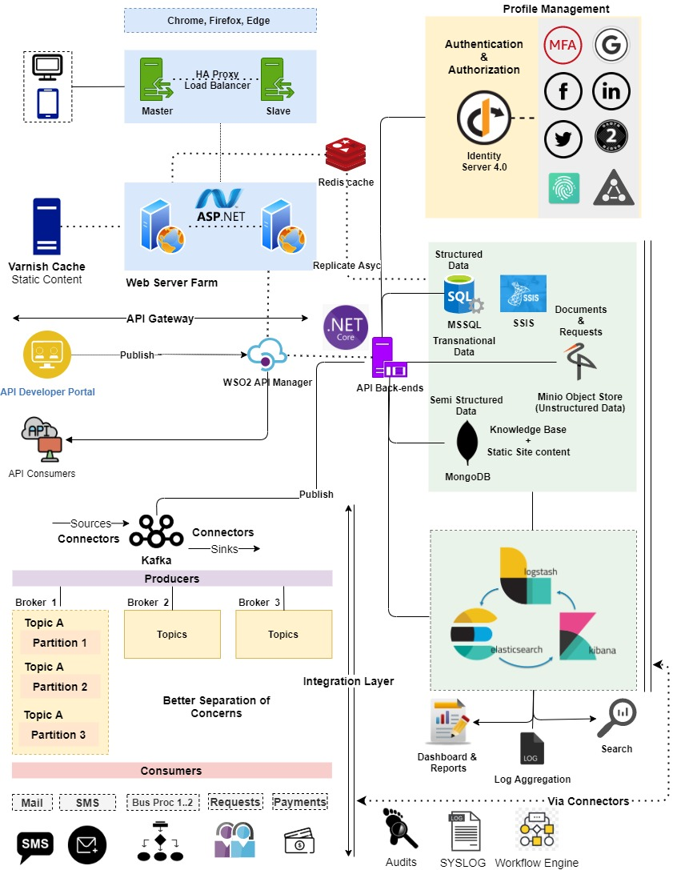

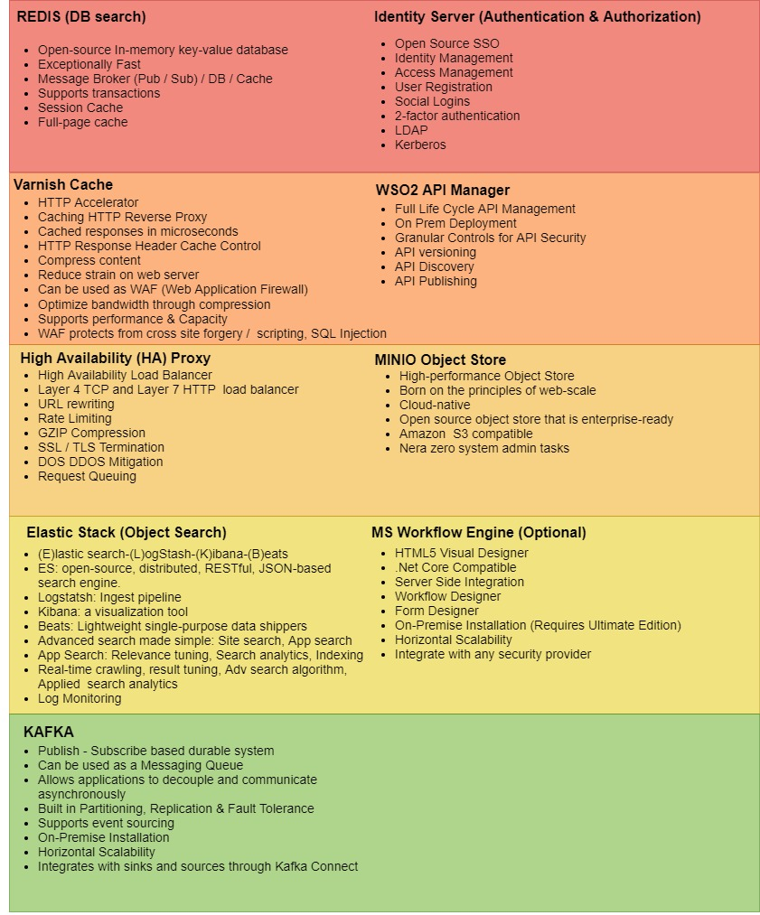

## Hosting Architecture – Test & Production

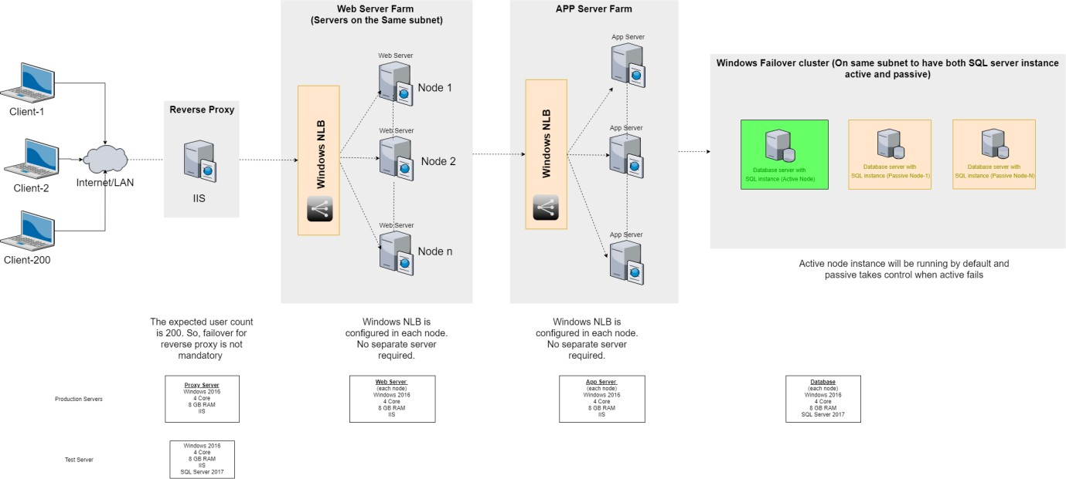Hosting plan involves allocation of web server farm, app server farm, reverse proxy and windows NLB configuration. Web server farm will have Web UI deployed. App server farm will have Rest API app deployed. Web server farm and app server farm will have more than one server. Windows NLB load balancing is used for fail safe cases. SQL server database is also maintained with active and passive configuration for fail safe cases.

# PROJECT ASSUMPTIONS

The project solution and technology is created from the initial understanding of the requirement shared with Verbat through mails and meetings. The proposed solution is based on the following assumptions:

## OBJECTIVE

* The requirement is to develop an integrated system with the functionalities as defined in the “Functional & Non-Functional” Requirements sections.

## DESIGN

* Client to provide Verbat with the branding guidelines.
* Client shall provide the text and associated images for the proposed application. Text should be provided in digital format preferably in MS Word 2013 or above. Client shall provide licensed images and logos in specified size & format requested by Verbat.
* Color theme shall be provided by the client.
* Verbat is free to use custom-made template for design, if required.

## DEVELOPMENT

* Requirements should be well defined, agreed and signed-off by the client.
* The requirements of the workflows, features, applications are assumed as simple & straightforward. If it is been identified with complex requirements, the scope & estimation may need to be revised.
* The proposed application front end will be in English and Arabic.
* Development is contingent upon timely feedback from client.
* The client will finalize the functional requirements and UI/UX/Prototype before the commencement of the development of the project
* Any workflows / applications / features which are not listed in the functional requirements section will be taken into consideration only after the scope & estimation get revised.
* Requirements should be well defined, agreed and signed-off by the Client
* The web application front end will be responsive.
* Supporting OS- As mentioned under “Technical Standards”
* Client will provide all necessary support and access for Active Directory Integration.
* Client will procure templates, SSL certificates, SMS gateway and email gateway details (if applicable).
* Necessary SMS API’s and documentations shall be provided by client.
* Data entry in the live application will be the responsibility of the client.
* Client will provide sample data to test the application
* Client shall provide clear directions on additional business process which may not be covered in this proposal. In such cases, the effort estimated provided in this proposal may be amended.
* Client will host and manage the application on infrastructure recommended by Verbat for managing database and application backup.
* All necessary plugins/licenses/tools needs to be procured/subscribed by the client
* Necessary software licenses will be procured by the client. Any other hardware/licenses/plugins required to complete this project (if any) will be procured by the client.
* Mobile application will be the same of web application wrapped with PhoneGap framework and converted as a mobile application.
* Internet connectivity is required for the functioning of the web application. The application requires a fast internet connection for real time communication.
* Verbat shall recommend architecture to support high availability and reliability. Unless implemented as per specifications, we cannot guarantee reliability and availability requirements
* IE 11 shall not be supported
* Payment gateway shall be provided by the client

# PROJECT DELIVERY

## PROJECT MANAGEMENT / PROJECT APPROACH

The Verbat development center strictly follows industry standards on quality. Our project management process is governed by the Verbat Quality Management system and is verified through internal audit programs.

Verbat will dedicate a project leader for the proposed implementation. Furthermore, Verbat proposes the client to identify one project manager (CSPM – Client-Side Project Manager) who will be driving all activities undertaken by the client, and will be the single point of contact for Verbat.

## ROLES & RESPONSIBILITIES

Verbat will assign its own dedicated Project Lead (*VPL – Verbat Project Lead*) for the client. The VPL will be responsible for planning and management of all activities related to the project. Furthermore, the VPL will work closely with CSPM, on all periodic status updates and will ensure high level visibility and comfort on the progress of the project.

### Project Team

|  |  |
| --- | --- |
| Resources | Count |
| Business Analyst | 3 |
| Project Manager | 1 |
| Technical Architect | 1 |
| Project Coordinators | 2 |
| Dot Net Team (Team Lead + Developers) | 5 |
|  |  |
| Database & Infrastructure | 2 |
| QA | 3 |

*Note:*

* *Business Analyst Team will have prior experience in Projects in Education Sector in UAE.*
* *Detailed CVs shall be provided upon the awarding of the project.*
* *These are indicative numbers. Recourses count would be finalized after requirement gathering.*

### Project Organization Plan and Stakeholder Analysis Plan

## COMMUNICATION MANAGEMENT PLAN

This Communications Management Plan sets the communications framework for this project. It will serve as a guide for communications throughout the life of the project and will be updated as communication requirements change. This plan identifies and defines the roles of team members as they pertain to communications. It also includes a communications matrix which maps the communication requirements of this project, and communication conduct for meetings and other forms of communication.

The Project Manager will take the lead role in ensuring effective communications on this project. The communications requirements are documented in the Communications Matrix below. The Communications Matrix will be used as the guide for what information to communicate, who is to do the communicating, when to communicate it, and to whom to communicate

|  |  |  |  |  |  |  |
| --- | --- | --- | --- | --- | --- | --- |
| **#** | **Meeting** | **Format** | **Frequency** | **Owner** | **Distribution** | **Escalation** |
| 1 | Weekly Status Update | Email | Once a week | Verbat PM | All project team members and major stakeholders | Project Head |
| 2 | Action Items Follow-up | Conference call & Email | Once in 2 weeks | Verbat PM / technical team | Respective stakeholders | Project Head |
| 3 | Steering Committee update meeting | Formal meeting | Monthly | Verbat / MOE PM | Steering Committee | Project Head |

Communications Conduct:

**Meetings:**

The Project Manager will initiate a meeting request at least 2 days prior to any scheduled meeting. It is imperative that all participants arrive to each meeting on time.

**Email:**

All email pertaining to the Project should be professional, free of errors, and provide brief communication. Email should be distributed to the correct project participants in accordance with the communication matrix. All attachments should be in one of the organization’s standard software suite programs and adhere to established company formats. If the email is to bring an issue forward then it should discuss what the issue is, provide a brief background on the issue, and provide a recommendation to correct the issue. The Project Manager should be included on any email pertaining to the Project.

**Informal Communications:**

While informal communication is a part of every project and is necessary for successful project completion, any issues, concerns, or updates that arise from informal discussion between team members must be communicated to the Project Manager so the appropriate action may be taken.

## SCOPE MANAGEMENT PLAN

Project Scope Management process are as follows:

1. Collect and Freeze Requirements – this first step is the process by which we define and document the requirements needed to meet all project objectives. Verbat will be collecting the requirements during the discovery phase after project initiation.
2. Control Scope – this is the process of monitoring/controlling the project/product scope as well as managing any changes in the scope baseline. It is the responsibility of the Project Manager to prevent scope creep and any deviation from the finalized scope will be subject to change management procedures. Refer section titled “Change Management” for change management plan.

## QUALITY MANAGEMENT PLAN

The Verbat development center strictly follows industry standards on quality. Our project management process is governed by the Verbat Quality Management system and is verified through internal audit programs.

The Quality Assurance activities are involved in all the stages of our Software development Life Cycle where product defects are reported by Verbat QA team, tracked fixed and retested until the product reaches to the Quality Standards set by the QA center.

## TIME MANAGEMENT

We at Verbat believe that a lack of effective time Management can have a negative impact on a project in the long run. Hence various activities are devised to manage the project time effectively.

|  |  |  |
| --- | --- | --- |
| **#** | **Activity** | **Description** |
| 1 | Schedule Management Approach | Project schedules will be created using Project Management tool starting with the deliverables identified in the project’s Work Breakdown Structure (WBS). Start and End dates and resource allocation will be maintained for each task in this schedule. |
| 2 | Schedule Control | The project schedule will be reviewed and updated as necessary on a bi-weekly basis with actual start, actual finish, and completion percentages which will be provided by respective team member |
| 3 | Schedule Changes and Thresholds | The project manager will review any requested changes to timeline and evaluate impact to overall delivery schedule. |

## RISK CONTINGENCY PLAN

Verbat has identified various risk factors associated with this assignment and understands the impact of these risk factors on the project schedules. The objective of this section is to highlight for both Verbat and client, the risk factors, to analyze the impact of the risks on project execution, and to propose strategies to control and reduce the impact of the risk factors. These various risks, which could arise during the project, are tabulated below along with mitigation implementation.

| **Type of risk** | **IMPACT** | Risk Mitigation | Risk Handling |
| --- | --- | --- | --- |
| Scope Creep | **H** | Functions and features will be detailed in system requirement document and will go through client approval. Once this document is approved, all changes will go through the change management process for impact assessment. | Proper change management procedure will be implemented |
| Delay in client feedback | **H** | The plan is prepared with sufficient lead-time for reviews and approvals.  The client will advise us on all dates connected to the document review and approval. | The request for feedback will be escalated if not attended to at the right time so that the schedules are not affected. Deemed acceptance criterion is finalized up-front and will be followed |
| Non-availability of necessary software, frameworks, database instances and infrastructure at client’s hosting environment (If hosting support is provided by Verbat) | **M** | Client will be informed in advance on these requirements. | Possible impact to schedule |
| Manpower attrition | **L** | All efforts will be made to ensure that all initiatives are process dependent. To mitigate risk Verbat/Client will train a person to ensure all back-ups are in place. | A new person will be appointed as early as possible, provided the required project-specific training and mentoring is in place - to minimise impact of attrition on the project |

*H-High, M-Medium, L-Low, NA-Not Applicable*

## PROJECT IMPLEMENTATION PLAN

Verbat will be providing the solution in a stand-alone fixed bid approach which ensures minimum viable solution for quick wins with core focus on the long-term business objective and outcome. Once the implementation is over, Verbat will initiate the application maintenance process (*once the maintenance contract is signed*) which continues to extend after the implementation.

## DELIVERABLES

* Project Plan
* Business Requirement Document (BRD)
* Technical Specification Document
* Solution Prototype
* High Level Architecture Diagram
* Source Code
* Software Build Tools
* Internal Test Results
* Software Release Documentation
* Released Software (Checklist)

## ESTIMATED DELIVERY TIME

07 calendar months are estimated for the development & deployment. Detailed project plan will be prepared after the complete requirement gathering.

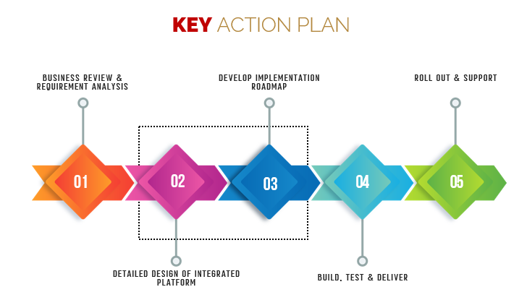

*Note:*

* *The above-mentioned timeline is in UAE Working Days*
* *The development initiation will start upon the design/UI/UX/Proto Confirmation*
* *The timeline required for design/UI/UX/Proto will be confirmed after the system study*
* *The initiation of the UI/UX/Prototype development is dependent on the confirmation of the SRS along with LPO, signed proposal and advance payment related to Development.*
* *The above-mentioned timeline for development is post the confirmation of Prototype.*
* *Any ‘Change Request’ from client, post the initiation of development which will impact existing approved features will be considered as a separate phase.*
* *Documentation submitted after project initiation and system study supersedes any proposal or documentation submitted during initial requirement gathering / discussion / negotiation*
* *Timeline is subject to revision post system study*
* *Project plan will be submitted post the confirmation of project with necessary payments*
* *The above timeline is based on the initial understanding of the requirement grounded on the details shared by client via RFP. If Verbat finds during the requirement gathering phase that the actual requirements uncovered are different form the original, this might affect the estimates provided and Verbat shall exercise rights to renege on the contract. Clarifications/Changes in the scope during system study/ analysis may call in for additional timeline.*
* *All approvals and queries regarding the client requirement and any queries which may hinder the project advancement at any stage should be answered by the client within 02 Business days from the time of initiation, failing which the time delay will get added to the actual effort and timeline which was estimated.*
* *Any delay in getting the approvals of deliverables from client will cause change in timelines and the revised timelines will be updated in weekly status reports shared with client after the project commencement*
* *On project confirmation, Verbat requires a lead time of minimum Thirty (30) days for resource mobilization.*

## RELEASE PLANNING

* Client will be informed about the release date and time through email.
* Client performs the UAT

# OUT OF SCOPE

With the ever evolving digital market, the requirement should be clear to both the parties involved, hence the importance of mentioning the out of scope details of the project. Following are considered to be out of scope while creating this proposal:

* Purchase of copyrighted images, fonts – if required by client
* Any language other than English and Arabic
* Migration of existing data / Database migration
* Content writing / proof reading / Data Replication / Manual data entry
* Content or image procurement or uploading or editing
* Test Cases, Load Testing, Stress Testing, Performance Testing, Security Testing, Penetration Testing, Regression Testing, End User Testing
* BI tools integration or reports generation engine
* Adding new features to the application other than mentioned in the functional requirements. Such requests will be handled via change management. For Change management details, please refer to section titled “Change Management” in the Proposal.
* Annual Maintenance Contract (Bug fixing, debugging, enhancements) – Please refer section titled “Maintenance and Support”, unless contracted for.
* Hosting Infrastructure and Maintenance (*web and email hosting)*
* Deployment in client server/ Physical deployment on-site / installation of the application in devices and physical connection, installation of system
* Integration with third-party, if any.
* Documentations and Deliverables other than mentioned under “Deliverables”.
* Backup solution and Disaster recovery
* Hardware Integrations / procurement and purchase
* Procurement of SMS gateway / payment gateway / email gateway
* SSL Purchase and installation, if any
* Relevant / related software libraries/Plugin/template purchases, if any
* Purchase of any tools/plugins/other resources/hardware required to perform any of the activities other than what is explicitly mentioned in this proposal.

# CHANGE MANAGEMENT

Any addition which comes out of the project scope, upon and after the launch of the application will be considered as change management. Verbat recommends the following change management procedure for the same:

* Changes will be implemented only after raising a change request.
* Change requests will be studied and an impact analysis will be performed on the existing work flow.
* Upon assessment of the impact, effort estimation will be calculated and raised as an additional requirement.
* The change request will be initiated only after receiving a formal approval from the client for the additional changes raised.
* Changes which are out of scope will be charged at per man day rate. *(refer financial proposal)*

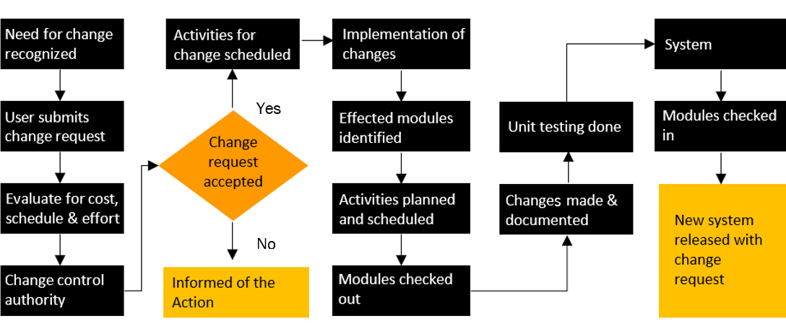

# MAINTENANCE & SUPPORT

* Maintenance contracts by default are supported as per the basic SLA terms.
* AMC with Basic SLA is charged at 30% of the total project value. Additional Effort/change management request will be added towards Total Value of the Project to determine the AMC value.
* Maintenance support is limited to providing application support for ensuring the consistency of the look-and-feel, bug fixes and user issues i.e. maintenance and support of the existing features of the application.
* Support does not in any way cover providing technical or other support to the users / hardware support / on- premise support / server support & maintenance / application deployment. The maintenance agreement does not include functionality changes or feature additions which are handled as change requests and will be charged as per the agreed man day rate *(refer financial proposal)*
* AMC charges will cover Off-Site Support and Debugging. Support includes E-mail, telephone and video conference (if required). In the event, the application is hosted with the client or if it is a client server development, necessary remote desktop connectivity should be provided for carrying out maintenance activities.
* All maintenance support will be executed by Verbat offsite team. In the event of any need for on-site work, all expenses incurred for such trips (flights, accommodation, meals, transportation) will be payable to Verbat by Client.
* Gap in AMC - In case if the client does not opt an AMC for a year and want to renew it after that period, 50% of the AMC amount for the year for which AMC is not taken will also be payable if the client wishes to renew the AMC contract.

|  |  |  |  |  |
| --- | --- | --- | --- | --- |
| **SLA Type** | **Max Response Time** | | **Max Resolution Time** | **Target** |
| Basic | 1  working day | 3 working days | | Request / incident / problem tickets |

*Note:*

* *Time zone applicable as per India Time Zones (3:30 GMT to 12:30 GMT, Monday to Friday)*
* *Any request by the client to use client preferred third party tools for issue tracking may call in for additional effort.*
* *Please note that the AMC support shall start only after all the necessary sign-offs (AMC Document) to this effect have been given.*
* *It is not mandatory that the client should opt for an AMC. The client will still be supported on an ad-hoc basis on an agreed man-day rate.*
* *AMC Payment Terms: 100% to be paid as advance.*

AMC Option: Client can opt for time and material based Annual Maintenance, the details of which will be shared post the completion of project.

# TERMS AND CONDITIONS

## ACCEPTANCE CRITERIA

* UAT (User Acceptance Test) sign off should take place within 14 Days from the first release of the application and the acceptance confirmation needs to be mailed to Verbat failing which Verbat will consider the project as approved by the client.
* Any comments and reasons for rejection need to be documented and the same needs to be sent as an email from the official mail id of client to Verbat on or before 14 days from the first release.
* Timeframe for acceptance for any further release will be mutually agreed and finalized between client and Verbat depending on the UAT Comments.

## WARRANTY

* Verbat shall provide a bug ﬁx warranty at no additional cost for 30 days from the date of acceptance of the project, for correction of any errors in the developed application that may be attributed to Verbat.
* However, this does not cover modifications by Client, or use of the application on an environment other than the proposed environment, or other circumstances outside Verbat’s reasonable control. In such a case Verbat reserves the right to charge for its services.
* All error corrections will be executed by Verbat offsite team. In the event of any need for on-site work, all expenses incurred for such trips (flights, accommodation, meals, transportation) will be payable to Verbat by Client.

## SOURCE CODE & INTELLECTUAL PROPERTY RIGHTS

* Upon completion of the Project and 100% completion of the payment, the client will have access to the source code except for proprietary codes, developer tools and third-party applications.
* The solution offered will be the intellectual property of the client and will be made available to the client on an “unlimited license” basis.
* No person or organization, other than Verbat or any person authorized by Verbat in writing, has any permission to modify/change the software solution to be eligible to get continued support from Verbat as per the support terms defined under this document.
* Verbat accepts no liability or damages of any kind arising out of use or non-use of the software delivered. The responsibility of testing of software lies with the client.

## GENERAL TERMS AND CONDITIONS

* Offer Valid for 90 calendar days from the date of submission of the Proposal.
* An average of 20 working days is assumed in a month.
* All the development activities will be carried out from our off-shore development center in India.
* All the documentations will be provided in English.
* Third party components may be used to develop this application.
* The scope of the project is to develop the application as mentioned in the technical proposal and will be finalized post the completion of the recommended discovery phase. If Verbat finds during the discovery phase that the actual requirements uncovered are different form the original, this might affect the estimates provided and Verbat shall exercise rights to renege on the contract. Clarifications/Changes in the scope during system study/ analysis may call in for additional effort and timeline. Any changes or additions will have to go through our change management process.
* This proposal is derived and concluded from either the RFQ /RFP/data shared via email / information transferred during an initial requirement analysis meeting / tele-conversation. Verbat reserves the right to change the terms of this proposal if the final terms (including the costing), features & functionalities and timelines are changed during the course of the project. Hence any fees quoted / timeline committed in this proposal may not be considered as final unless agreed upon and signed by both parties.
* Application will be best viewed in the environment mentioned in “Technical Configurations”
* All source codes and other project artifacts will adhere to the Verbat document templates and internal coding standards. Any additional request will be analyzed and charged accordingly.
* The documents delivered to the client include the ones mentioned under ‘Deliverables’ and these will adhere to Verbat’s internal document standards. Any additional request will be analyzed and charged accordingly.
* The security standards will adhere to Verbat’s security standards (OWASP). Any additional request will be analyzed and charged accordingly.
* Acceptance criteria shall be based on the clauses which were mutually discussed between Verbat and client at the Requirement Analysis phase. The same will be documented and approved by both parties through official emails.
* In the event that the Client requires any extension of the proposed acceptance schedule, the associated effort and cost of such extension will be mutually reviewed.
* If the project needs to be put on Hold / Stop, a minimum notice period of 1 week is required along with the duration of the holding period. Thereafter Verbat will make a final decision based on the request.
* If deployment is done in the client’s server, Verbat will not be held responsible for any performance issues arising due to hardware malfunctions.
* The Client is responsible for all data-backups in case the application is not hosted on the Verbat server.
* All source codes will only be delivered or uploaded on the production server after the due payments are made to Verbat.

## GENERAL ADMINISTRATIVE, TECHNICAL & FUNCTIONAL ASSUMPTIONS

* Detailed system study is required before the start of the project.
* During the requirement gathering phase, authorized personnel from the Client’s side are expected to be available for discussions and finalization of the HLD (High Level Design), before development commences.
* Type of reports, formats, workflow if under the scope of the project, need to be specified by the Client before the project sign off.
* Verbat assumes that all sign-offs from the Client will be provided within the agreed and specified timeframe.
* The client should provide the relevant information and data, well in advance of the execution of the related activity. Non- availability of this information or data may lead to an interruption of work, which may result in a delay in delivery as well as additional costs to the client.
* The Client should possess a server with the technical specifications recommended by Verbat for the proposed application.
* The Client will be provided with a one-time training (train the trainer) on how to use the application via a video conference (maximum of 4 hours). Additional training requests will be charged at cost to the client.

# Project References

**Client Name – Ministry of Education (MOE)**

Project Name: Open Educational Resource Platform (OERP)

Location: Dubai, U.A.E

Ministry of Education has requested Verbat to develop a UAE- Open educational resource platform (OERP). The aim of this platform is to provide a centralized online platform where UAE and others can view, share and contribute their contents. Furthermore, this portal will allow UAE-MOE to track and monitor the progress through a dashboard. All information related to OER such as issue date, source, current state, future state, release dates along with best practices shall be captured.

**Client Name - Al Ain University**

Project Name: Document Management and Archiving System

Location: Al Ain, UAE

Established in 2004, Al Ain University (AAU) opened the doors to its first student cohort in 2005. Constantly innovating, AAU expanded its facilities by opening a second campus in Abu Dhabi in 2008, offering programs in Business and Law. AAU is licensed to operate under the auspices of the UAE Ministry of Education (MoE).

Verbat was assigned to develop a Knowledge Management System for Al Ain University for the purpose of storing and retrieving the documents related to the semester of an academic year. Approval workflows were implemented for the uploaded documents.

**Client Name – UAE University**

Project Name: e-Library

Location: Al Ain

Verbat was assigned to develop an e-library system with scientific database search engine

Application System which is to facilitate active participants to search for scientific information using various facets and filters. Auxiliary information to scientific journals, publications and trait ontology. Search results are represented in color codes too.

**Client Name – Rulers Representative Court (RRC)**

Project Name: Smart System

Location: Abu Dhabi, U.A.E

Verbat was assigned to develop a new Document Management and Archiving System called Smart System. The SMART System offers an effective solution for RRC enterprises to manage activities like citizen’s affairs, protocol, support services etc. It enables internal users to log requests, approve and follow up until it completes the RRC document process cycle for the various day to day business operations. The Smart system app allows the client to submit documents using pre-designed templates and follow up on the status of petitions. It is a web application with mobile capability to facilitate the entire lifecycle of workflow activities related to document processing.

**Client Name – Sharjah Commerce and Tourism Development Authority (Government of Sharjah)**

Project Name: Integrated Permit Issuance and Inspection Online System

Location: Sharjah, U.A.E

Established in 1996, the Sharjah Commerce and Tourism Development Authority (SCTDA) is tasked with promoting commercial and tourism activities in the emirate of Sharjah. Sharjah intends to provide a sustainable tourism product with a unique and distinct tourism experience in the desert areas of the emirate. This is geared towards attracting the interest of various tourism companies, specifically tour operators, to focus on Sharjah when organizing desert trips and desert adventures activities within these areas. Consequently, this would be beneficial to the tourism sector and will contribute further to Sharjah’s economy. Hence, the Sharjah government has decided to organize desert tourism activities through this project; the issuance of permits to all tour vehicles entering the desert areas of Sharjah for desert safari activities owned or operated by tour operators along with the day to day inspection tasks carried by inspectors who can issue fines and attach evidences for further actions.

Sharjah Tourism resource deployment model comprises of Offsite resource (Verbat Resource) and Onsite Project Manager (from client’s side).

**Client Name – Department of Seaports and Customs (Government of Sharjah)**

Project Name: Customs Clearance Portal

Resource Deployment Model: Offsite

Department of Seaports & Customs, Sharjah, Sharjah Seaports Authority manages the three ports of Sharjah Port Khalid, Port Khorfakkan and Port Hamriyah. The three ports of Sharjah are the leading trade gateway to the UAE and handle all kinds of ships and caroges. The three ports in total have 33 berths, handle in excess of 10 million tons of bulk and general cargo, over 2.5 million TEU's of containerised cargo, around 52000 ro-ro units and over 6500 vessels in a year. Cargo volumes handled have been recording consistently steady growth over the last several years.

The application is a Web based customs clearance portal for collecting and safeguarding customs duties and for controlling the flow of goods in and out of the country. The application includes Separate modules for Shipping, Free zone Clearance, Airport Cargo, Creek and Vehicle clearance. It provides a User-friendly interface to declare the shipment.

Sharjah Ports resource deployment model comprises of Offsite resource (Verbat Resource) and Onsite Project Manager (from client’s side).

**Client Name – Ministry of Foreign Affairs**

Project Name: VISA Scheduling System

Location: Dubai, U.A.E

A web-based application for the visa applicants and respected sponsors to schedule appointment for the security verifications. The system allows online payment facility. The application features include option for the sponsor to schedule appointments, option for the super admin to manage country and sites, manage other admin users and set e-mail/SMS notifications

**Client Name – Carrefour (Majid Al Futtaim Retail)**

Project Name: Delivery System

Location: Dubai, U.A.E

Founded in 1992, Majid Al Futtaim is the leading shopping mall, retail and leisure pioneer across the Middle East and North Africa (MENA).

A remarkable business success story, Majid Al Futtaim started from one man’s vision to transform the face of shopping, entertainment and leisure to ‘create great moments for everyone, every day’. It has since grown into one of the United Arab Emirates’ most respected and successful businesses spanning 13 international markets, employing over 27,000 people, and achieving the highest credit rating (BBB) among privately-held corporates in the Middle East.

A system to initiate online Grocery store (e-Commerce) with managing the orders streamlining the pick, pack and delivery. The main objective of the project was to allocate pickers by key strength in picking category (fresh, frozen and dry) and allocate orders to pickers (with handheld device) and master pickers. Other featured include performance dashboard with graphics, scanning and storage of orders, delivery of orders using handheld devices etc.

**Client Name – Majid Al Futtaim L.L.C (Carrefour) Hybris Project**

Project Name: Software Quality Assurance Managed Services

Resource Deployment Model: Hybrid (Onsite + Offsite)

Founded in 1992, Majid Al Futtaim is the leading shopping mall, retail and leisure pioneer across the Middle East and North Africa (MENA).

A remarkable business success story, Majid Al Futtaim started from one man’s vision to transform the face of shopping, entertainment and leisure to ‘create great moments for everyone, every day’. It has since grown into one of the United Arab Emirates’ most respected and successful businesses spanning 13 international markets, employing over 27,000 people, and achieving the highest credit rating (BBB) among privately-held corporates in the Middle East. Carrefour testing team comprised of 20 resources inclusive of Onsite Project Manager, Onsite Test lead and Offsite Test Engineers

**Client Name – Hutchison Ajman International Terminal Limited (HAJT)**

Project Name: POS and e-Payment Middle ware system

Location: Ajman, UAE

Hutchison Ports Ajman is a member of Hutchison Ports, the port and related services division of CK Hutchison Holdings Limited. With the transfer of industry best practices by Hutchison Ports, effective allocation of resources, and the introduction of new equipment, we have been improving operational efficiencies and services.

Hutchison Ports is the world's leading port investor, developer and operator with a network of port operations in 52 ports spanning 27 countries around the globe. Over the years, Hutchison Ports has expanded into other logistics and transportation-related businesses, including cruise ship terminals, airport operations, distribution centres, rail services and ship repair facilities. Verbat was assigned to develop POS and ePayment MiddleWare system for HAJT for the purpose of making payments related to the port activities for their consignees. The payment was carried with the integration with e-dirham.

**Client Name – MBC**

Project Name: Security Inspection System

Location: Dubai, U.A.E

Smart Security System facilitates a sophisticated and structured approach to execute the daily security checklist to be used by the security patrol users. In addition to the ability of recording concern/issues as well to be viewed at any time as reports.  The application includes different users like Super Admin, Branch Admin, Inspector, Resolver and Viewer. The Inspector user reports patrol issues and concern issues using android mobile application. Branch admin assign the patrol issues to the resolver. Viewer will be able to see the issues and concerns related to the particular branch.

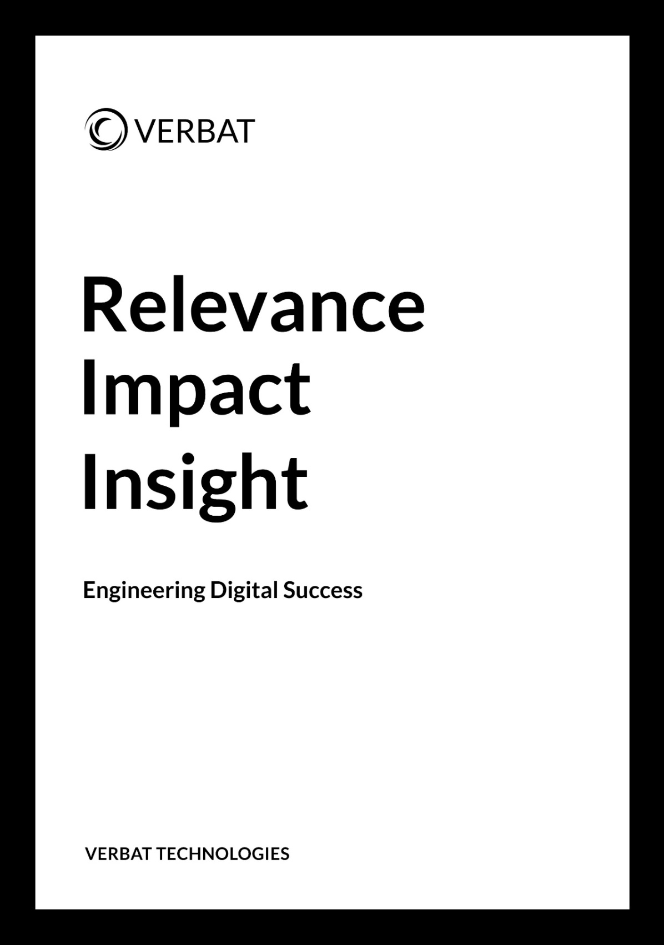

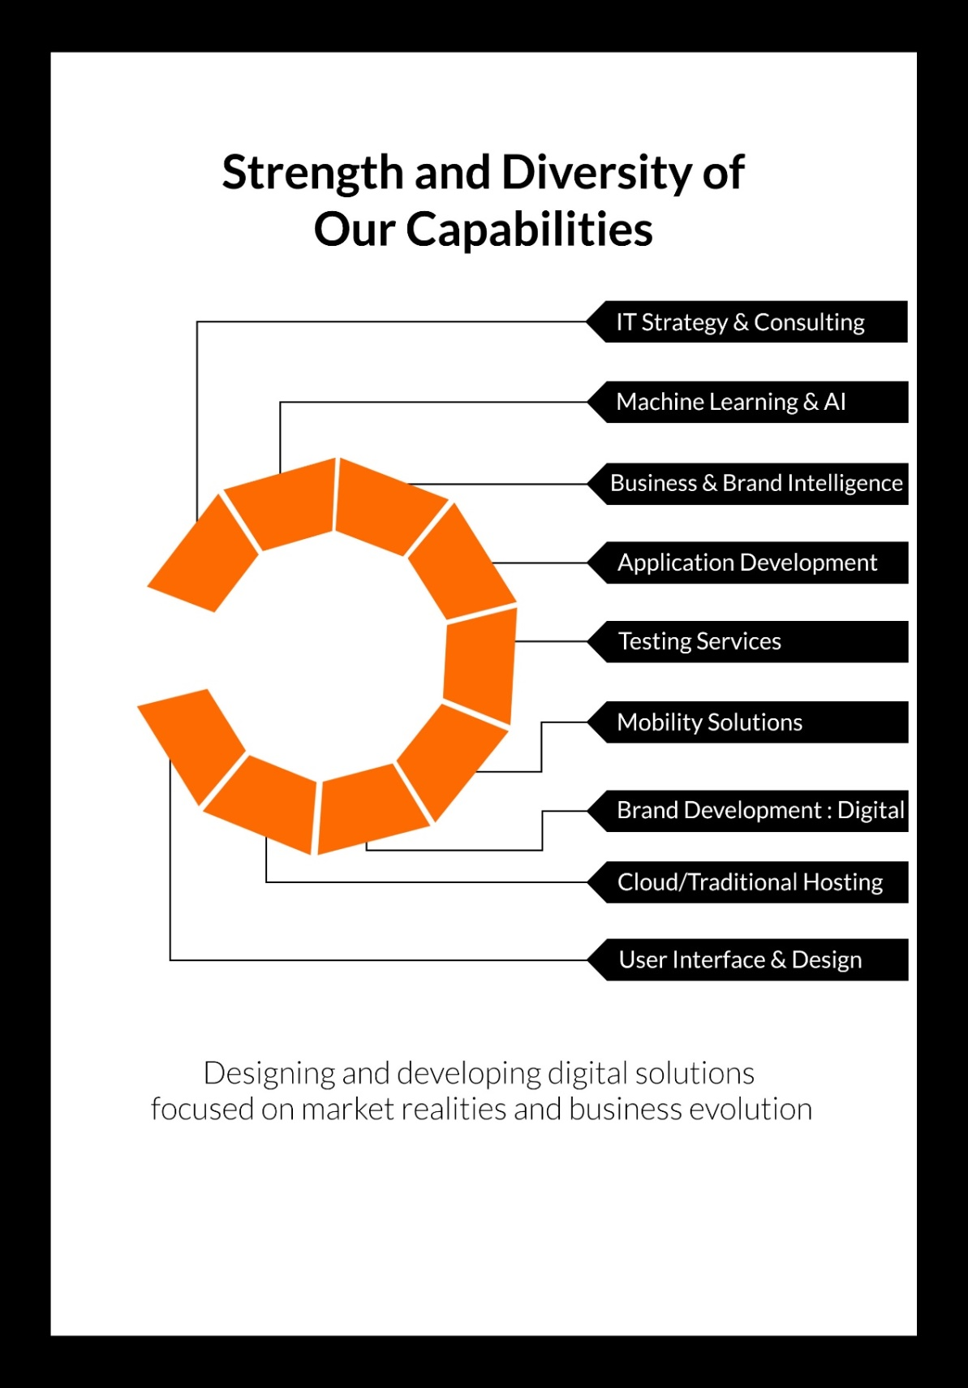

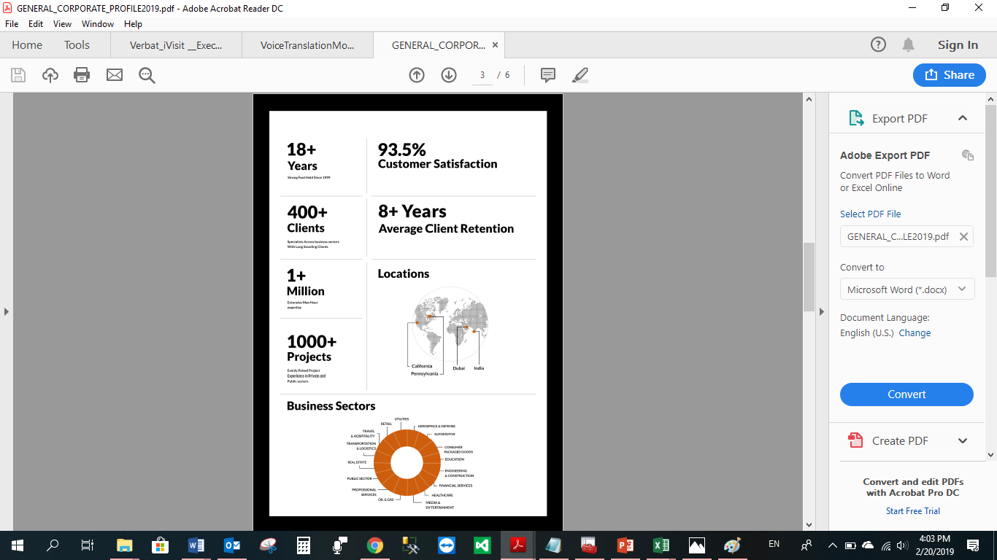

20 Years

Strong Foot holds since 1999

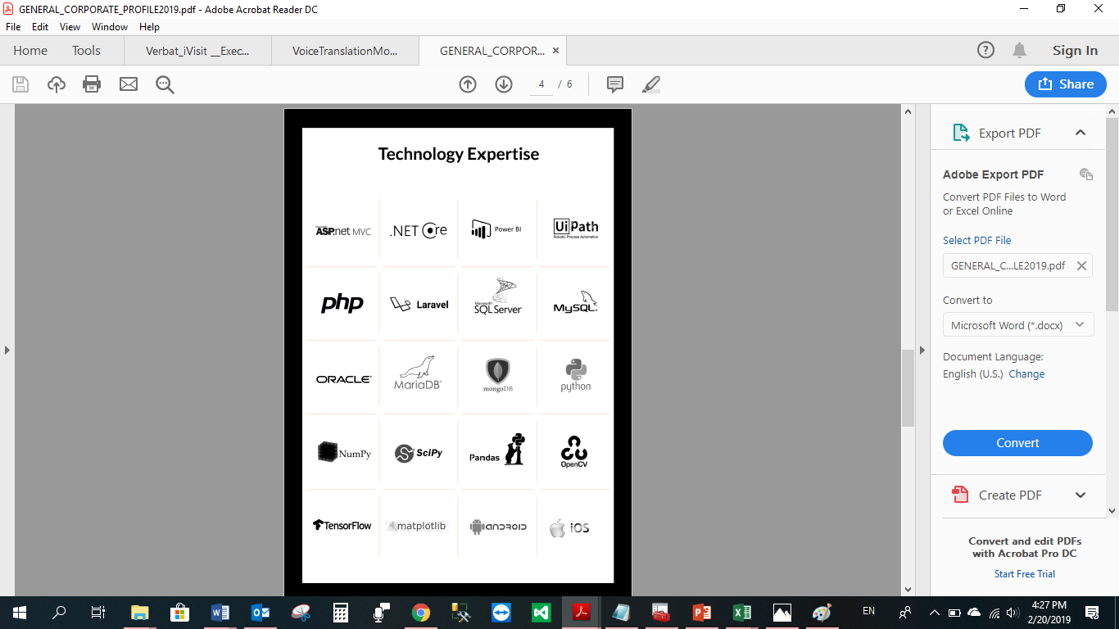

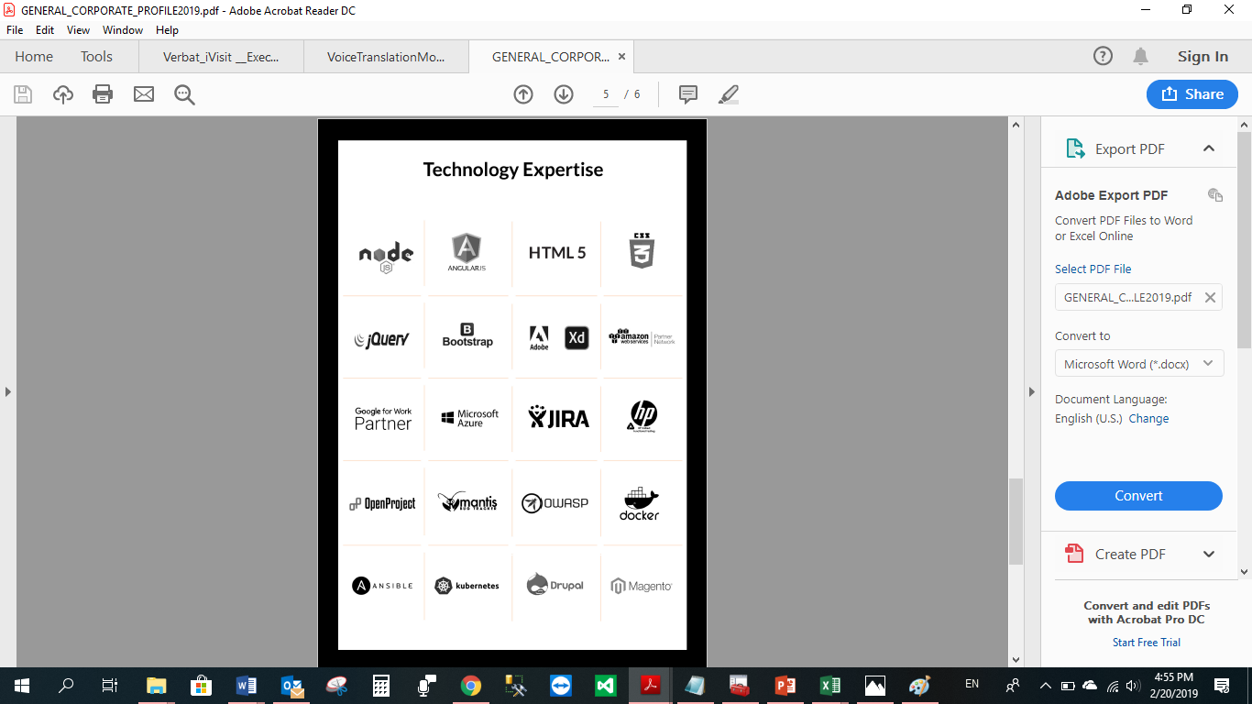

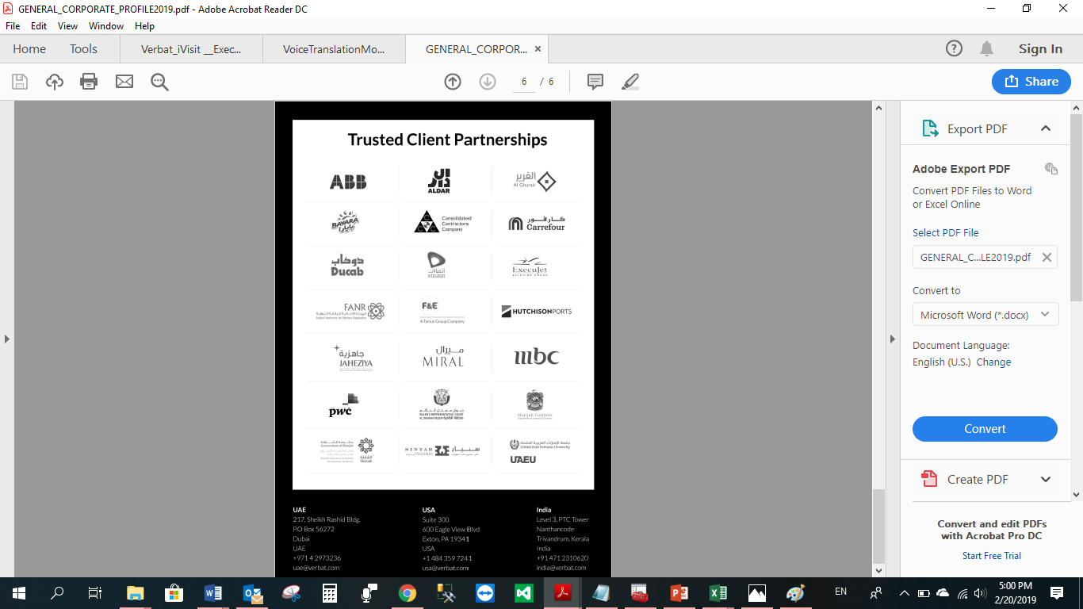

**WITH OUR**

**SINCERE THANKS.**

CONFIDENTIALITY NOTICE:

This Proposal is conﬁdential and contains proprietary information and intellectual property of Verbanet Technologies LLC. Neither this proposal nor any of the information contained herein may be reproduced or disclosed under any circumstances without the express written permission of Verbanet Technologies L.L.C (hereby known under its brand name of Verbat in the United Arab Emirates). 2019. All Rights Reserved.